2014 Arts Integrated Projects, Lessons, Units
Ingham ISD and MSU-FCU Institute for Arts & Creativity at Wharton Center
Kennedy Center Partners in Education Program

Title (enter title of lesson/unit/project): “It’s Personal”
Enter grade level(s):  5th | How many students were involved?  5 sections = aprox. 155
Enter academic subject(s):  English Language Arts, Technology | Enter art form(s): Visual Arts
Enter name(s) of primary faculty responsible for design and delivery: ELA: Colleen Martell, Marcie Boles, Sheryl Meisterheim, Jill Darrow, Joni Clarke, Alex Brooks, VA: Colleen Shoup Tech: Jessica Smith

Enter school and district name: Greyhound Intermediate School; Eaton Rapids Public Schools

1. Description (write a paragraph description):
Students will create a personal portfolio of work representing their 5th grade year. The portfolio will include writing: essay and personal narratives, figurative writing, and “Where I’m From” poems; visual art: self portraits, “Where I’m From” collages, hidden word art (based on opinion essay, narrative writing or figurative writing), cover art, portfolio construction and ceramic “self reflection mirrors”; technology: “word photo” collages, “Where I’m From” poem with photo and voicethread, and graffiti name art.

- Purpose of the project/lesson/unit:
To create a reflective portfolio representing their 5th grade year as they transition to 6th grade (Middle School). The project incorporates/ integrates curriculum from the three content areas, makes connections, and results in an extensive keepsake portfolio of work.

- We accomplished by:
As a staff we collaborated by planning the project together. We worked cooperatively across content areas, communicated our objectives and enhanced the critical thinking skills of our students and ourselves.
Students created different pieces to add to their portfolios in art, in language arts and in technology. They then brought these pieces to art in order to put together their portfolios. They will be using this portfolio to think about what they learned about themselves as learners and what skills and character traits they currently have or may need to strengthen in order to be successful in middle school.

- Describe duration (this was a project embedded in a six week unit, other):
This was an on going project over a period of several months. Many of the pieces layered onto each other by building on components of the project throughout the school year.

- Describe any necessary context:
ELA: Writing genres
VA: Self portraits, value, self reflection

2. Name the Arts Standards/Objectives met in the project (limit of 2-3):
Art. VA 1115.5 – Develop a sensitivity and understanding of how personal experiences can influence the development of art work.
Art.VA 115.5 – Analyze how are conveys ideas to express one’s individuality
Art. VA115.6 – Explore and understand the impact of digital media and technology in the creation of artwork (Technology)
Technology:
3-5.CI.2. Create original works as a means of personal or group expression.
3-5.CC.1. Interact, collaborate and publish with peers, experts, or together employing a variety of digital environments and media.
3-5.CC.2. Communicate information and ideas effectively to multiple audiences using a variety of media.

3. Name the Academic Standards/GLCEs met in the project (limit of 2-3):

W.5.1
1. Introduce a topic or text clearly, state an opinion, and create an organizational structure in which ideas are logically grouped to support the writer’s purpose.
2. Provide logically ordered reasons that are supported by facts and details
3. Link opinion and reasons using words, phrases, and clauses (e.g., consequently, specifically).
4. Provide a concluding statement or section related to the opinion presented.

4. Describe the process (first we had students do “x,” then “y,” then “z”):
Writing –We taught various forms of writing including narrative, argumentative, expository and expression (poetry) For each form we first modeled specific strategies and structure, and then took students through the writing process.
Because of our encore rotation schedule, the order in which content was taught varied by classroom. However, all students created self-portraits in art class, and created a “Where I am from” collage. When students had a published writing piece, they brought that writing to art class and used it to create their word art. Published writing was also brought to the technology class in order to create word art and “Where I’m from” poems.
First students brainstormed topics, then they wrote, then they used those ideas/writings in order to create visual art and technology pieces.

Insert pictures of students at work (3-4 pictures).
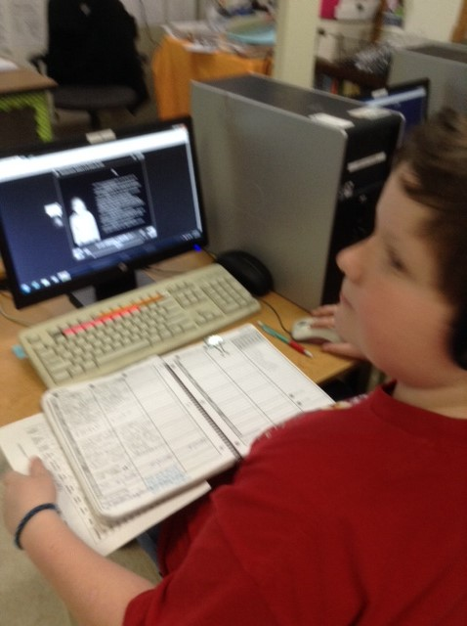
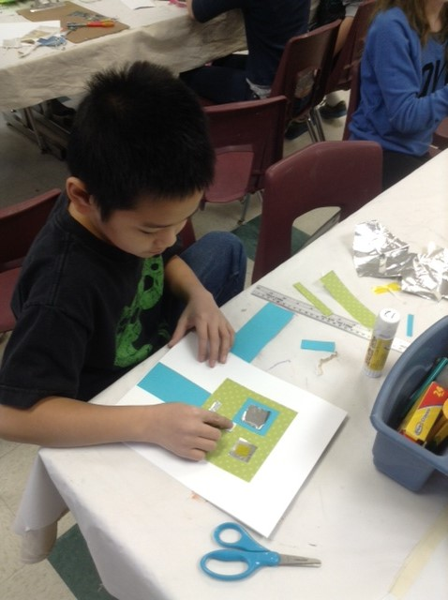
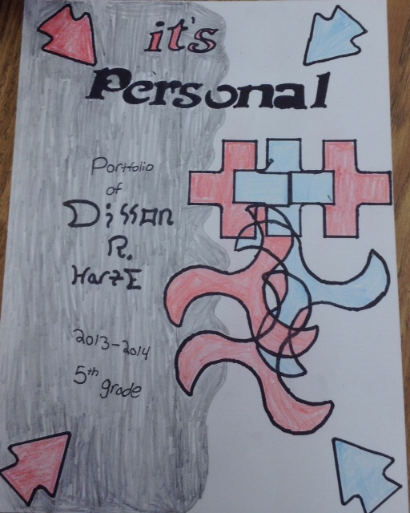
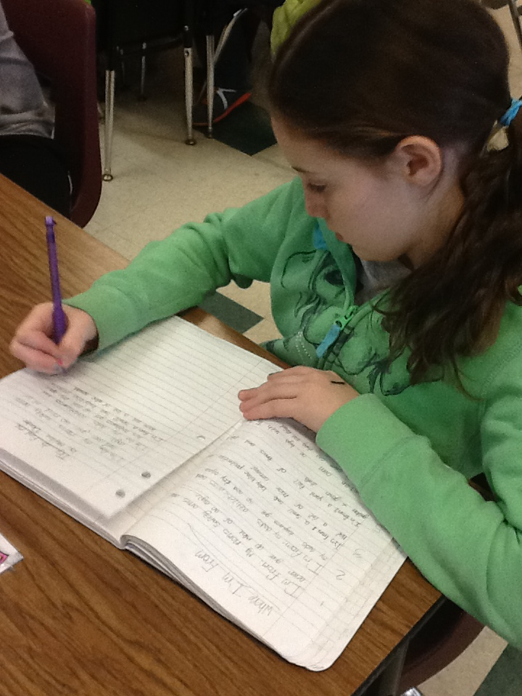

- Describe materials and/or resources used to carry out, augment, enhance this project (guest artist, performance, field trip, use of salvaged items, school supplies):
ELA –in order to write our “Where I’m From” poems, teachers modeled lessons that were given to us by Glennis Redmond. We followed her plans that we were taught at last years Arts Integration classes. A local resident who is an expert on Eaton Rapids history came in as a guest speaker to provide background knowledge for our poems and collages.
Art- poster board for portfolios, local articles (about Eaton Rapids) for collage, personal photos, New programs in technology
Technology-our teacher wrote a grant so that we would be able to purchase a license for the use of voicethread

5. Describe the product/task (students produced……):

Students produced an extensive 4+ page double sided, 11X14 accordion style portfolio of work from writing, visual arts and computer art. Students were engaged because all of the material in the portfolio was directly related to/about themselves and they chose what pieces to include. This was an on-going process where students frequently had the opportunity to revisit, revise, reword, or rework their pieces.

Insert pictures of student work (3-4 pictures)
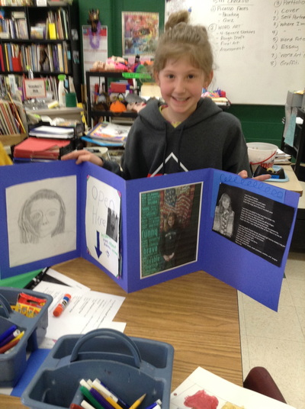
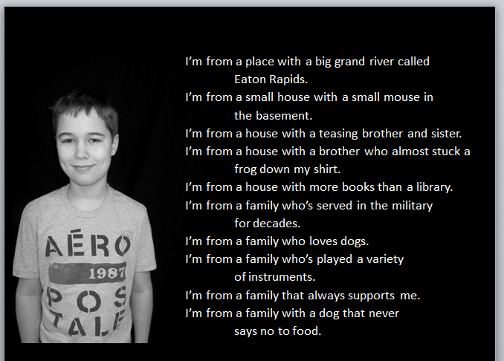
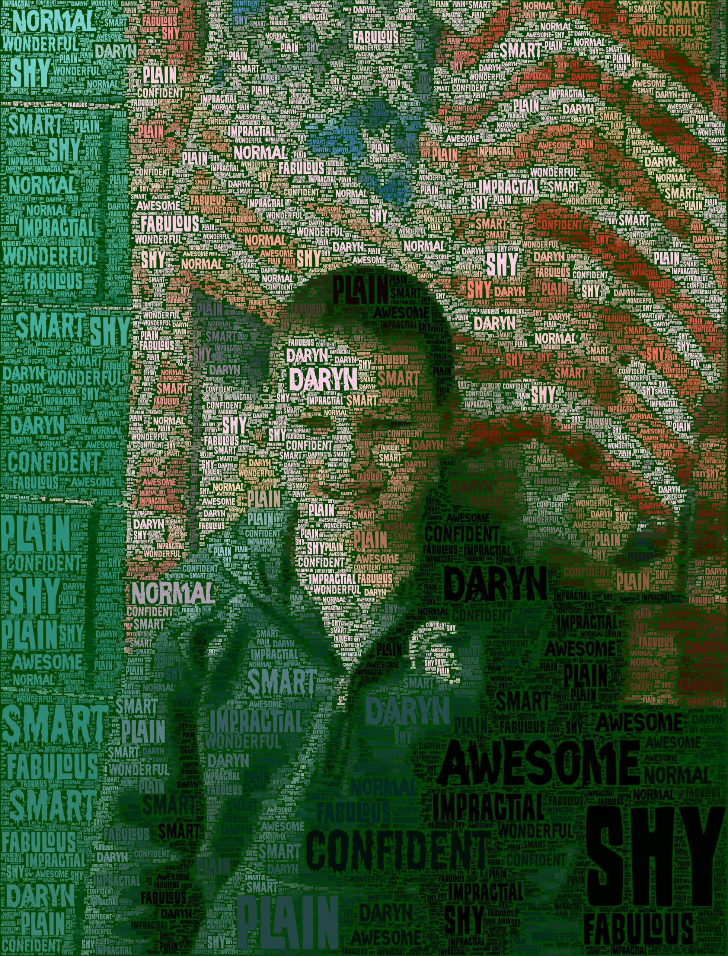
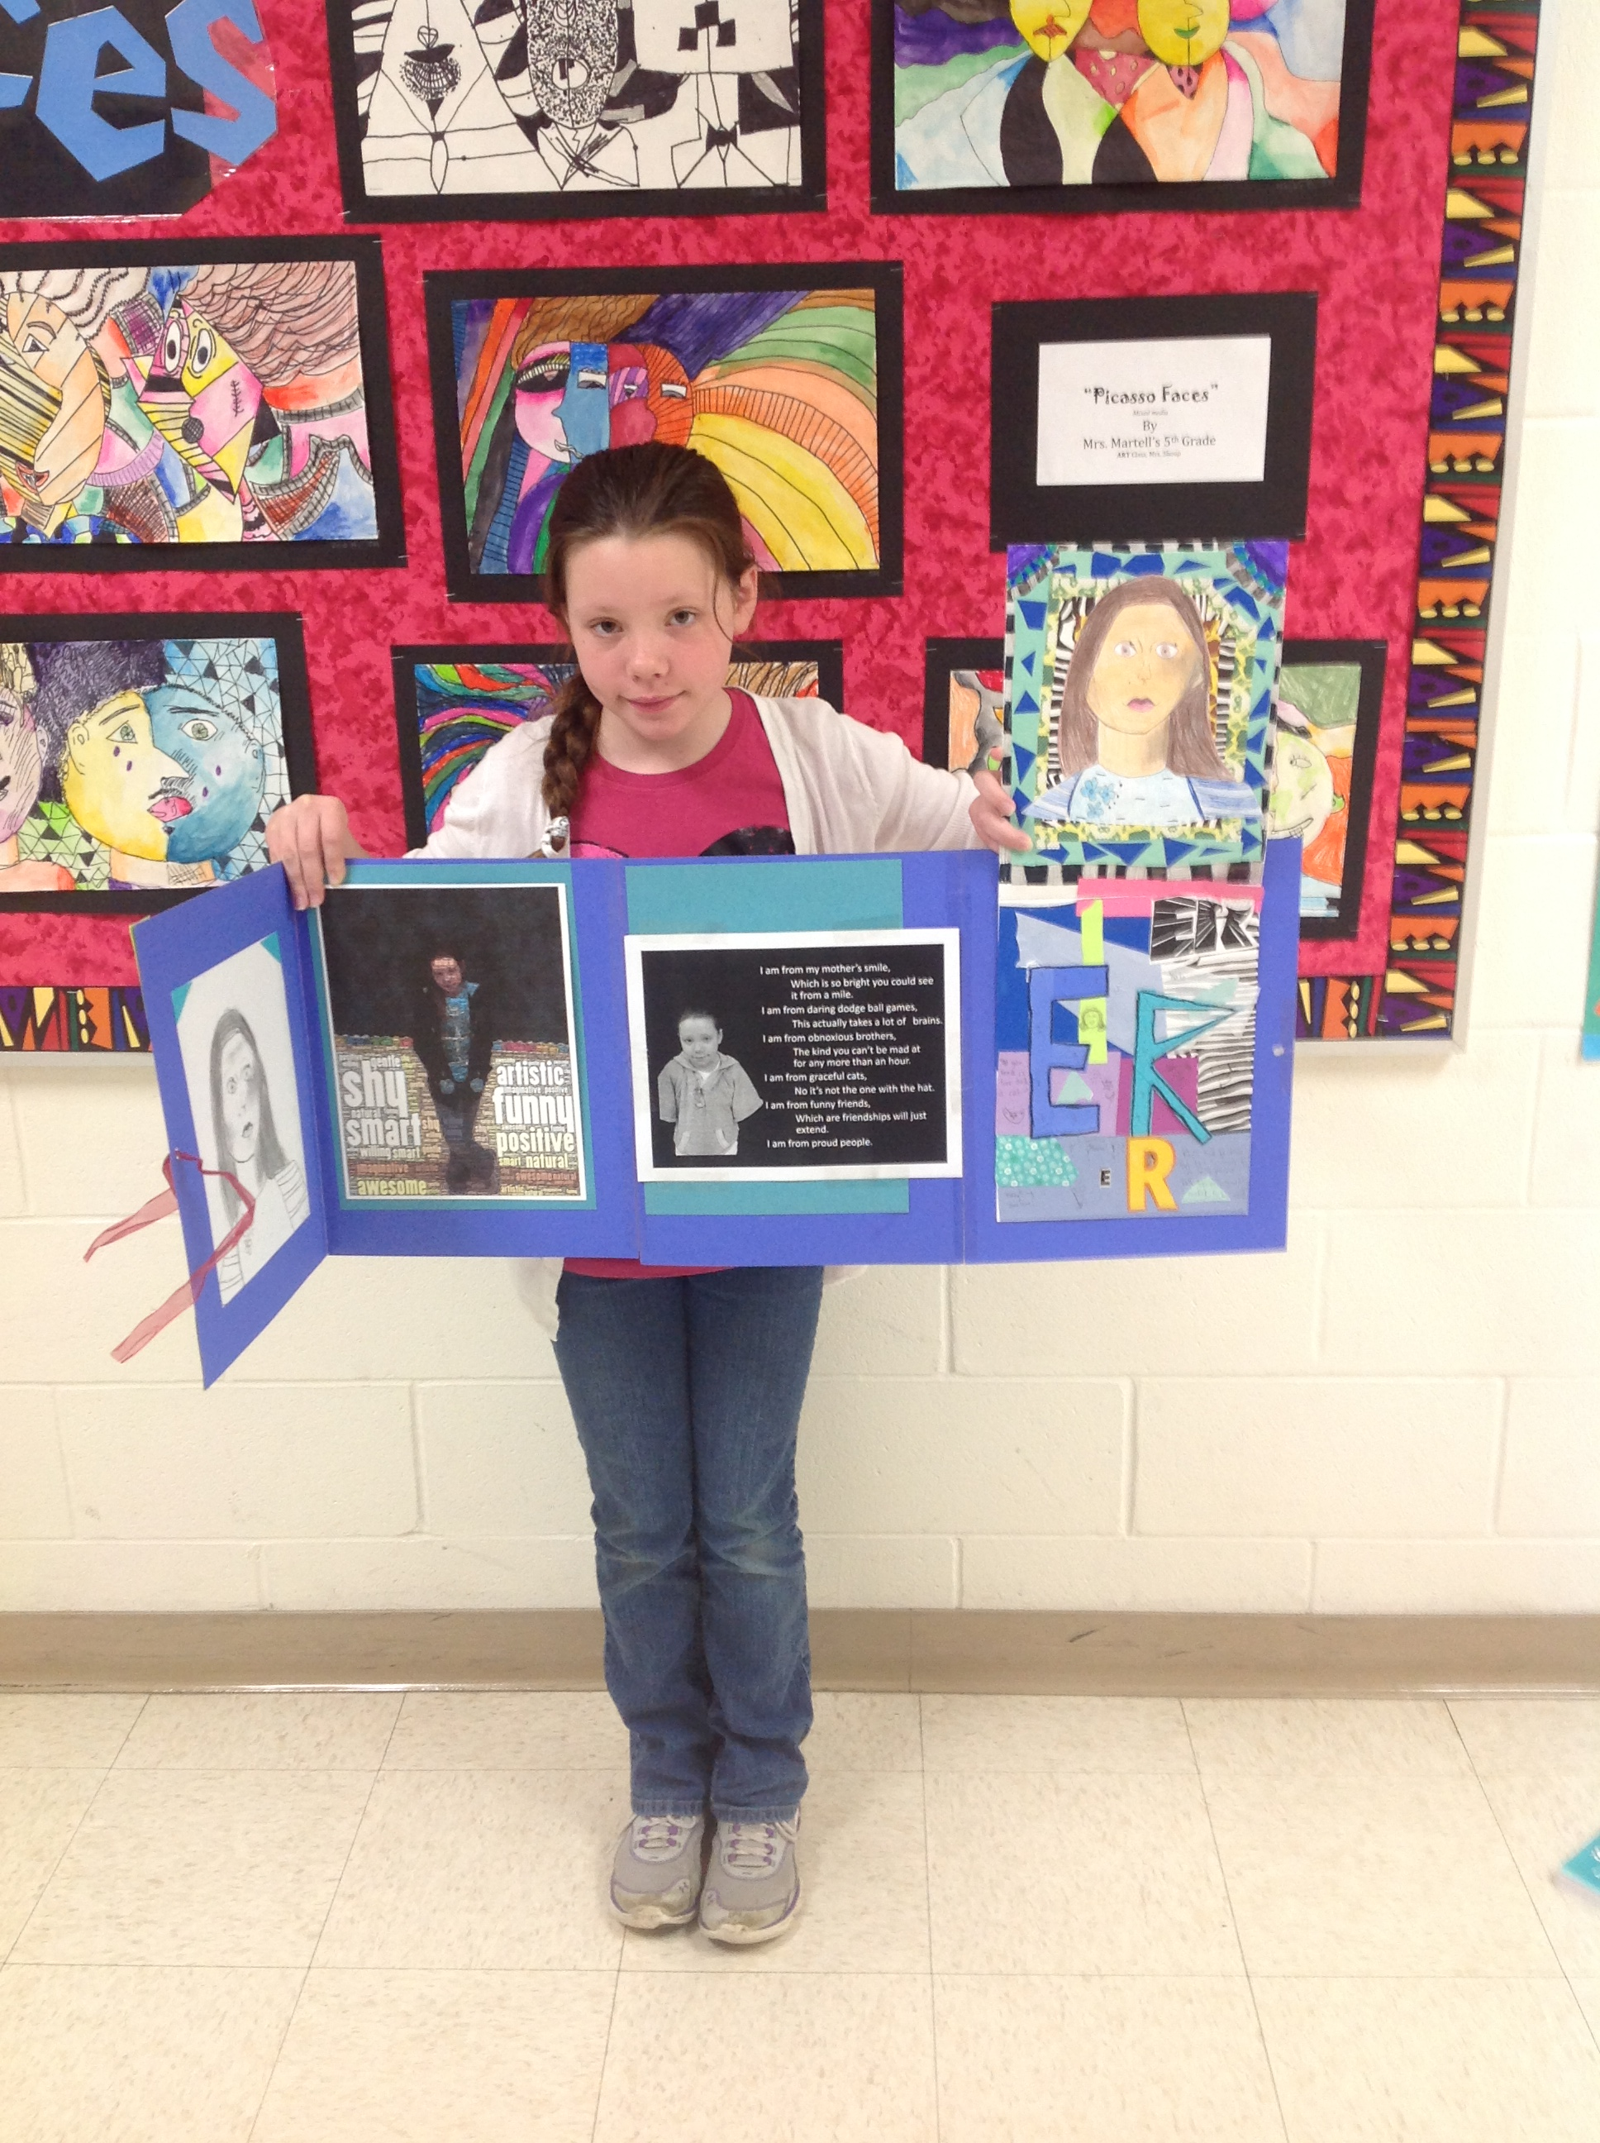

6. Describe how you know what students learned or didn’t learn: (This is your assessment question.)

The very objective of this project is in itself assessment. We want the students to use this project to reflect on what they have learned about themselves. The last writing piece that students do will be a How-To essay. The essay will turned into a power point plan they make for themselves on How To Survive Sixth Grade. This plan will be presented to the class. The intent is that by doing this year-long portfolio, students are able to say which attributes and skills they already have, and which will have to be strengthened in order to be successful next year.

Along the way we had several other assessments in place such as: self-assessment check lists in art, self-assessment checklists in computers, pre and post essay tests, writing on-demand prompts, self-assessment rubrics, and reflective journal writing.

7. How would you characterize the student work? Did it meet your expectations, exceed, neither? Do you have observations to
share about specific students and their performance?

Art – Some students excelled and some did not complete work. More struggled with word art. We tried using “figurative writing” with one class instead of the essay choices. The thought being that they had “painted” a picture with words so it would lend itself to visual illustration, however, it was still a challenge for many. Ceramic mirror frames: most students enjoyed creating these and represented themselves well. Overall, the project as a whole was challenging, but a very good opportunity for students to revisit their work and improve it upon reflection.
Language Arts- most students wrote thoughtful, meaningful poems that were full of figurative language. It was so powerful to see their pictures and to hear their poems being read from their own voices. It was an experience I won’t forget and I hope they won’t either.
Some of the portfolios far exceeded expectations and some fell short, but for the most part, students did what we asked them to do by applying what was taught.

8. Were there any unanticipated outcomes for students related to engaging students in this work? (describe)

We found that in both art and language arts the connections the students made with the work and the content spiraled and piggy-backed on each other. It was so evident that the creative process is a circular process, not linear. Work that we did in both the general education and art classes caused more reflection and revision, which then led students to closer mastery of a skill. It ended up being a spiral of learning that consisted of layering, revisiting, and revisioning. Multiple contacts with content helped students in making connections and solidifying a concept. These are skills that will serve them well as they enter the secondary grades.

9. What would you do differently if you were to repeat this project/lesson/unit?
- Perhaps fewer art projects to compile (change “word art” to another art project?)or try a change in focus?
- Heart of the story/illustration and switch with another class or turning points more interpretation/personal narrative/comic strip.

10. Please rank in order (1 the most, 7 the least) the overall goal for engaging students in arts integration that most closely
characterizes your intentions for engaging your students in the AI project described.
___1__ We wanted to increase student engagement
__3___ We wanted to deepen the learning in the academic subject and the art form (accomplished by tackling together vs.
apart)
__5___ We wanted to provide access to content through the use of multi-learning modalities
__6___ We wanted to differentiate content/product/process
__2___ We wanted to cultivate habits of mind that make kids life-long learners
__9___ We wanted to focus on 21st Century skills (creativity, collaboration, critical thinking, communication)
__7___ Other (describe and rank order)

11. Please assign a percentage (0-100%) with your estimate of the extent to which the lesson/unit/project focused on
provided students the opportunity to…
100_____ engage in the creative process
100_____ use critical thinking skills
100_____ collaborate effectively
100_____ communicate effectively (verbally, written, performance, music, visual arts)

