2014 Arts Integrated Projects, Lessons, Units
Ingham ISD and MSU-FCU Institute for Arts & Creativity at Wharton Center
Kennedy Center Partners in Education Program

Title (enter title of lesson/unit/project):
Enter grade level(s): 4th Grade | How many students were involved? Approx. 90 students
Enter academic subject(s):  Reading and Writing | Enter art form(s):  Visual Arts, Technology, and Music
Enter name(s) of primary faculty responsible for design and delivery:
Pam Babbitt, Amanda Bahmer, Stephanie Brown, Colleen Shoup, Jessica Smith, Chris Rupp, Jane Wiborn
Enter school and district name:
Greyhound Intermediate School—Eaton Rapids Public Schools
1. Description (write a paragraph description):

One of the 4th grade common core standards is that students will write their own myth or legend. As a team we decided that having students learn about myths would challenge their imagination, expose them to literature that most would have little background knowledge of, open the door to cross-curricular activities, and keep their interest sustained over a period of time.

- Purpose of the project/lesson/unit:

Students will identify the characteristics of a myth/superhero and be able to incorporate those characteristics into their own writing.

- We accomplished by:

Students collaborated, cooperated, enhanced their critical thinking skills, and communicated throughout the process.

- Describe duration (this was a project embedded in a six week unit, other):

This is an ongoing project that builds on each component that continued throughout the year.

- Describe any necessary context:

ELA/writing genre—myths

2. Name the Arts Standards/Objectives met in the project (limit of 2-3):
Art Standards (GLCEs, HSCEs)
- CS1: Apply skills and knowledge to perform in the arts:
ART.VA.I.4.3 Analyze and reflect on the elements of art and design to communicate ideas.
- CS2: Apply skills and knowledge to create in the arts:
ART.VA.II.4.1 Synthesize the use of s variety of materials, techniques, and processes to problem solve in the creation of art.
ART.VA.II.4.2 Synthesize knowledge of elements of art and principles of design to creatively communicate ideas.
- CS3: Analyze, describe , and evaluate works of art:
ART.VA.III.4.2 Recognize that art may serve functional purposes, be purely decorative, or serve multiple purposes.
- CS5: Recognize, analyze, and describe connections among the arts; between the arts and other disciplines; between the arts and everyday life:
ART.VA. V.4.3 Identify connections between technology and the arts.
ART.VA.V.4.4 Demonstrate cross-curricular connections through a culminating event.

Technology 3-5 Standards(GLCEs)
- 3-5.CI.1. Produce a media-rich digital project aligned to state curriculum standards (e.g., fable, folk tale, mystery, tall tale, historical fiction)
- 3-5.CI.2. Use a variety of technology tools and applications to demonstrate his/her creativity by creating or modifying works of art, music, movies or presentations
- 3-5.TC.1. Use basic input and output devices (e.g., printers, scanners, digital cameras, video recorders, projectors)

3. Name the Academic Standards/GLCEs met in the project (limit of 2-3):
W.GN.04.01—Myth Writing L.CN.04.02—Listen to while demonstrating appropriate skills
R.NT.04.02—Myth Reading

4. Describe the process (first we had students do “x,” then “y,” then “z”):

Students wrote an individual myth or superhero story. Students collaborated with 3 to 5 peers and write a group story. Students then did a story board and created a mask portraying their myth or superhero character. Next, students went to technology and created a movie trailer for their story. Finally, in music they composed music to go with their movie trailer.

Insert pictures of students at work (3-4 pictures).
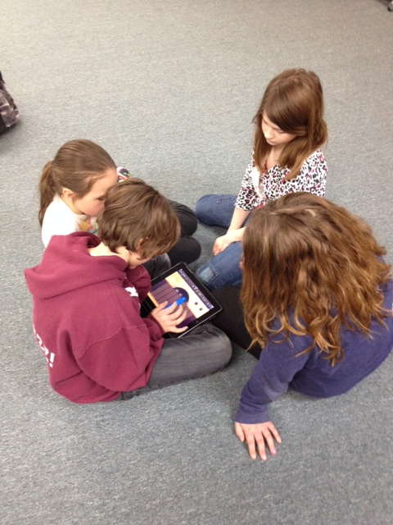
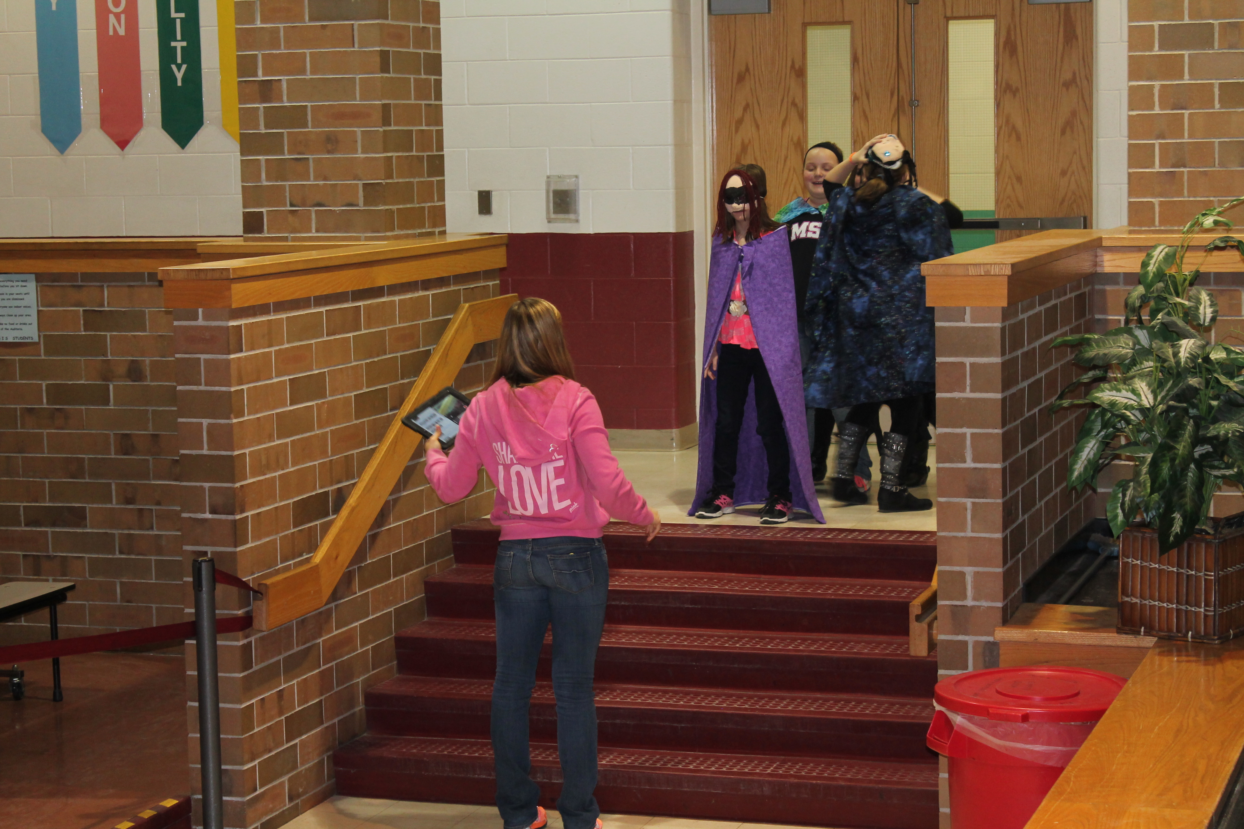
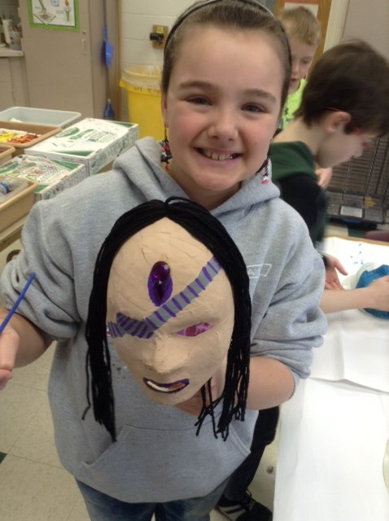
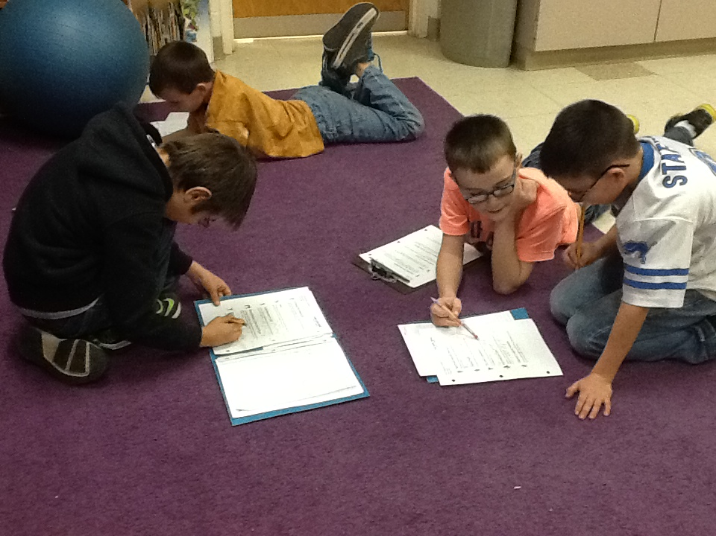

- Describe materials and/or resources used to carry out, augment, enhance this project (guest artist, performance, field trip, use of salvaged items, school supplies):

Charlotte Blake Alston retold myth stories and legends as a visiting artist to a few of our classrooms. We also attended “Tales From the Arabian Knights,” at the Wharton Center.
Materials: Readers Theater scripts, myths and superhero anthologies and books, video clips

5. Describe the product/task (students produced……):

Students produced group myth/superhero stories, mask portraying their character, movie trailers advertising their story, and music to accompany their movie trailer.

Insert pictures of student work (3-4 pictures)
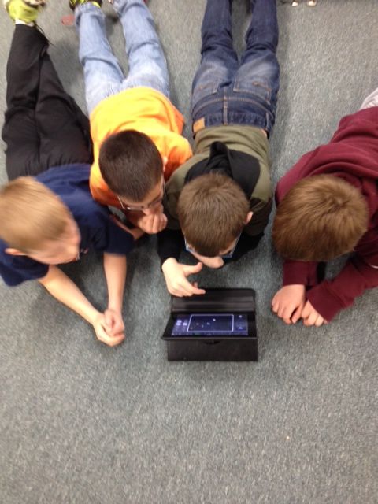
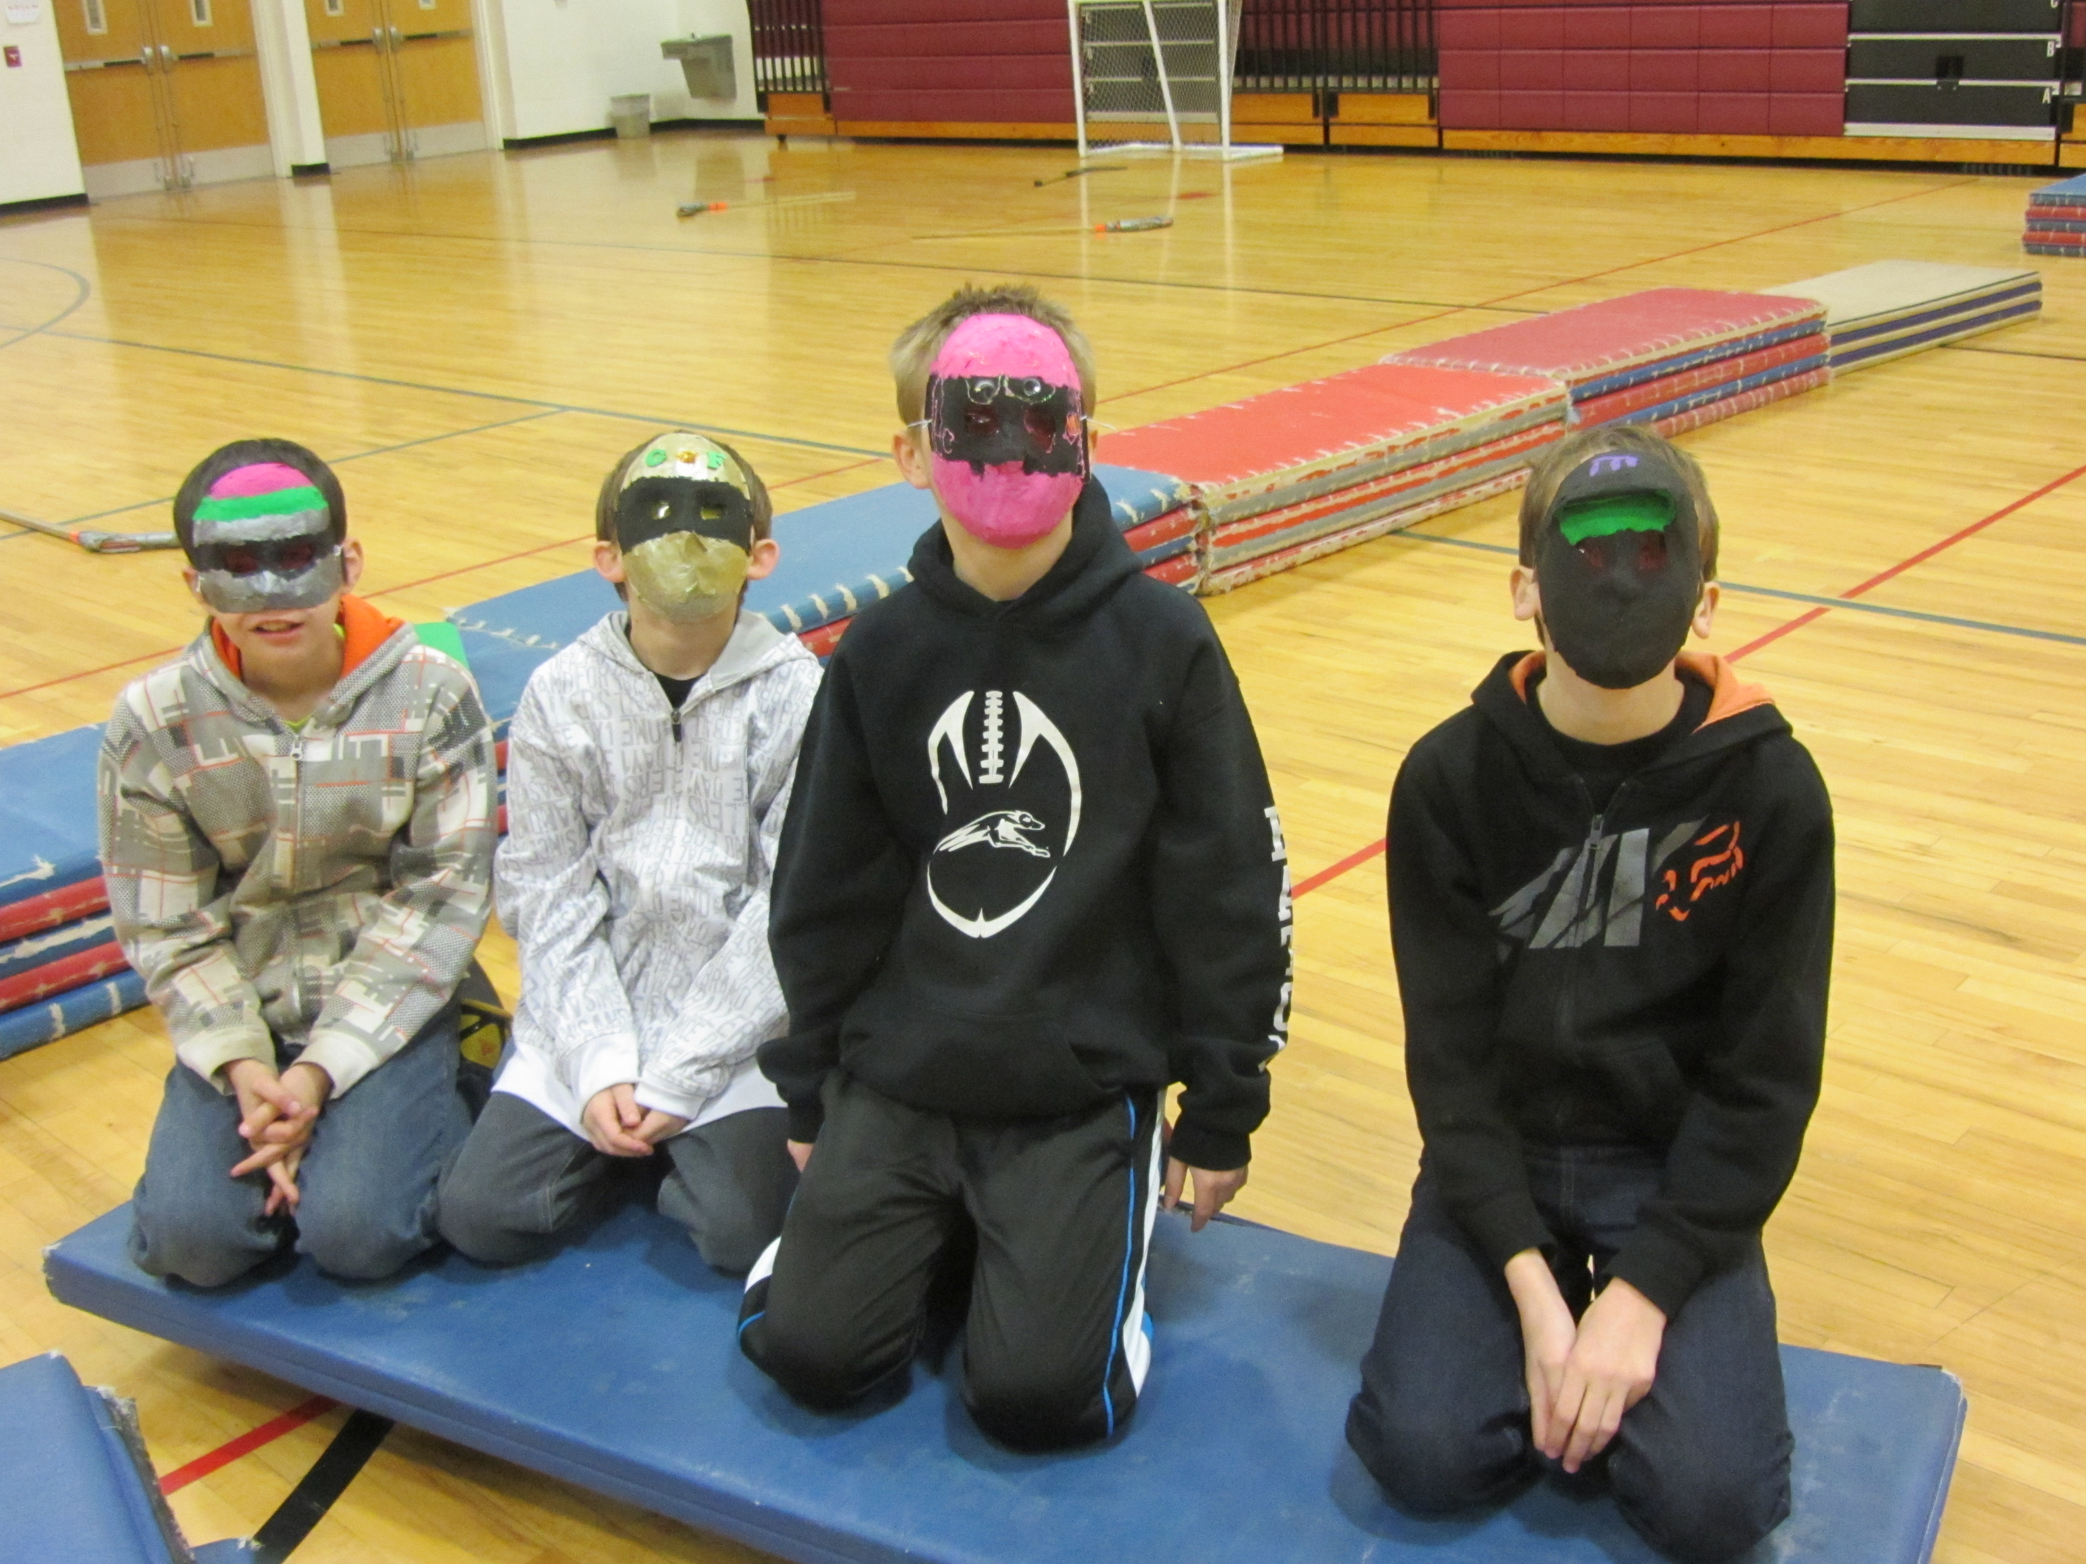
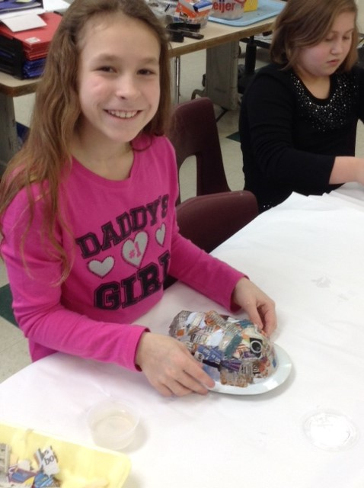
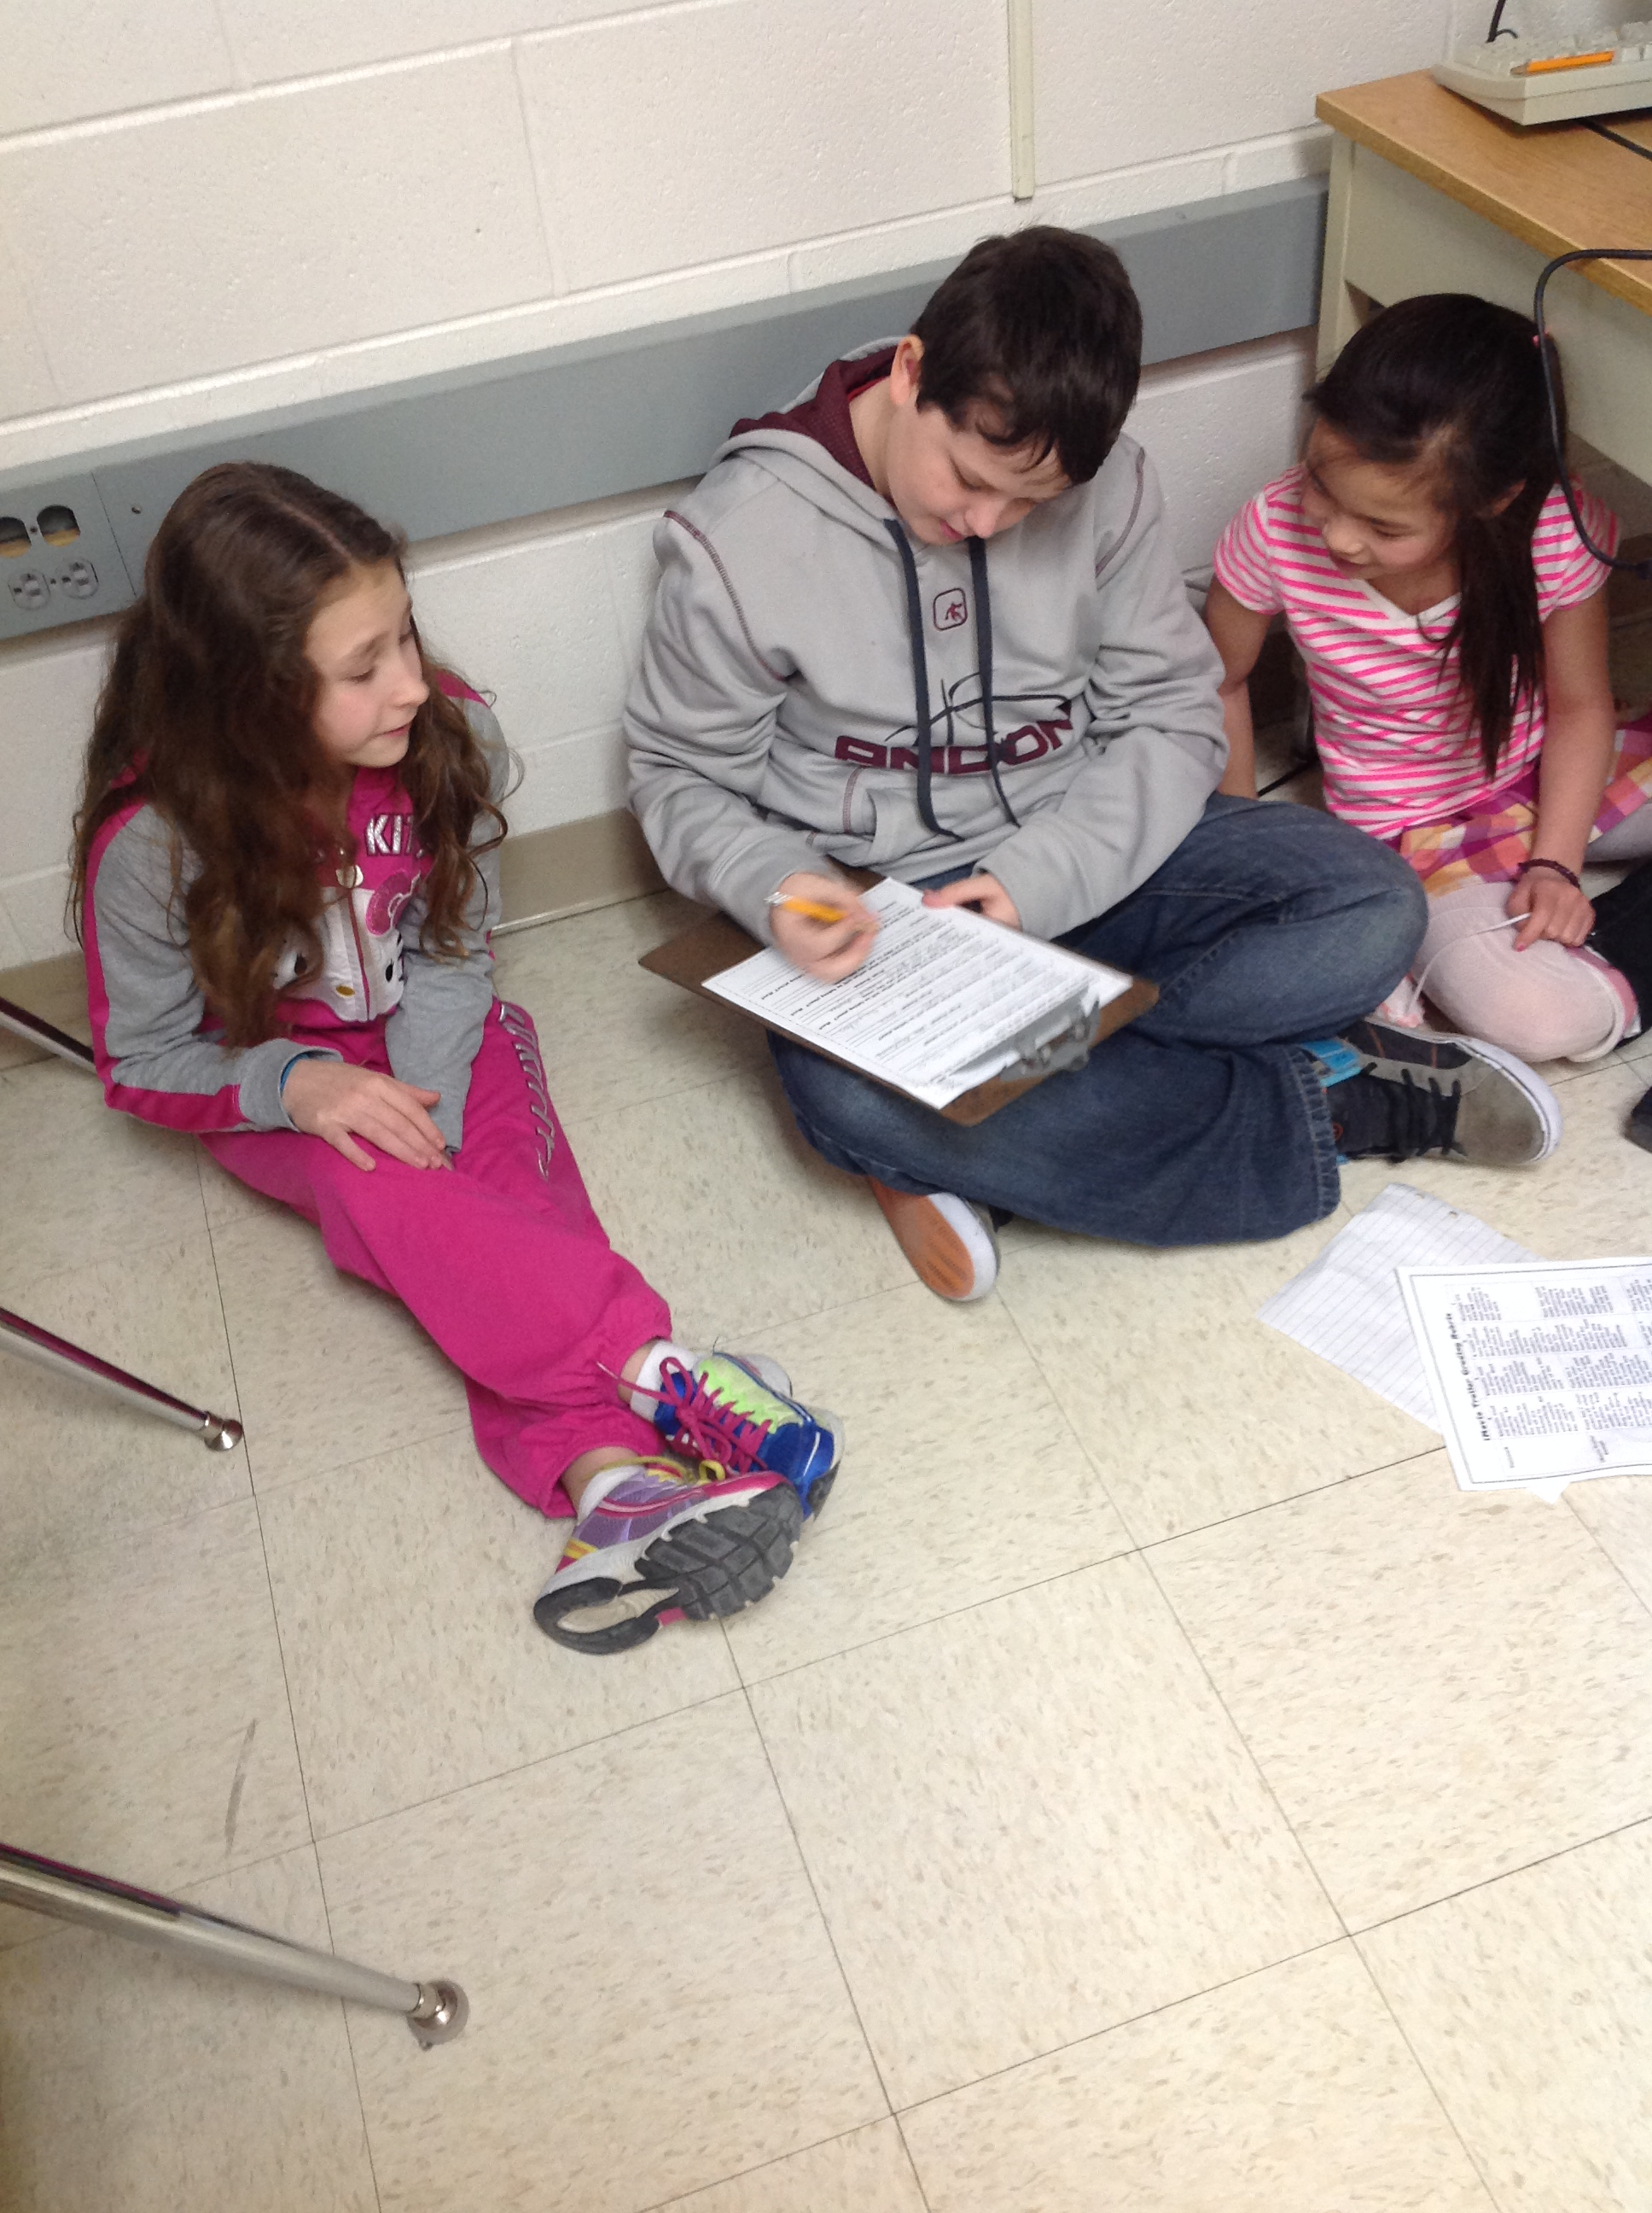

6. Describe how you know what students learned or didn’t learn: (This is your assessment question.)

Pre-test, post-test, self-reflection journaling, myth/superhero rubric

7. How would you characterize the student work? Did it meet your expectations, exceed, neither? Do you have observations to
share about specific students and their performance?

Our expectations were met; however, we plan to develop the group story more next year.

8. Were there any unanticipated outcomes for students related to engaging students in this work? (describe)

The project to much longer than anticipated due to inclement weather, making the project feeling as if it were drawn out and disjointed. More students chose to write myths this year than in the past.

9. What would you do differently if you were to repeat this project/lesson/unit?

Next year we are planning on placing more emphasis on the group myth/superhero story rather than the individual myth/superhero story.

10. Please rank in order (1 the most, 7 the least) the overall goal for engaging students in arts integration that most closely
characterizes your intentions for engaging your students in the AI project described.
__1__ We wanted to increase student engagement
__2___ We wanted to deepen the learning in the academic subject and the art form (accomplished by tackling together vs.
apart)
__4___ We wanted to provide access to content through the use of multi-learning modalities
__3__ We wanted to differentiate content/product/process
__6___ We wanted to cultivate habits of mind that make kids life-long learners
__5___ We wanted to focus on 21st Century skills (creativity, collaboration, critical thinking, communication)
_____ Other (describe and rank order)

11. Please assign a percentage (0-100%) with your estimate of the extent to which the lesson/unit/project focused on
provided students the opportunity to…
100% engage in the creative process
100% use critical thinking skills
100% collaborate effectively
100% communicate effectively (verbally, written, performance, music, visual arts)

