- Go to Mrs. Smith’s Website
- Click on Arts Integration (Top Row)
- Scroll to the bottom and click on the Grafcreator picture (Looks like the picture above)
7. When you like your Graffiti name click the PRINT SCREEN Button on your keyboard
8. Open MS Word
9. Push the Ctrl +V to paste your picture into Word

5. Select design elements
6. Select color
- Type your name in this box
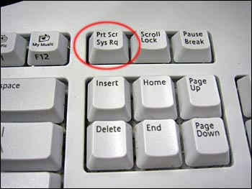
10. Double click on the picture (circles should appear around the edge)
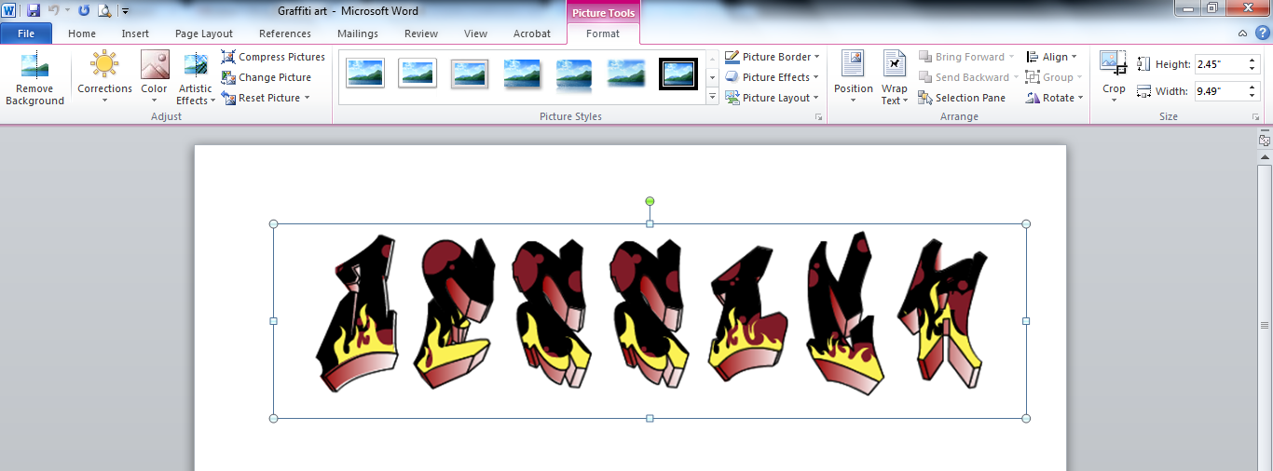
11. Click on Crop- Drag Black Corners to the area you want to crop- Click on the Crop button on your toolbar when you have your area you want to keep selected.
12. You will save this 2 times!
1. Click File- Save As- Computer (left side) Your Username (center under networks)
Save as: Graffiti (your first and last name)
2. Click File- Save As- Computer (left side) Shared Drive- click on: Communications- Click on: your teachers folder with their name and graffiti (example Clarke Graffiti)- Save as: Graffiti your first and last name.

