Wordle
- Open your Personal Narrative or Essay in MS Word
- Press CTRL+A to select all your text
- Press CTRL+C to copy
- Minimize MS Word
- Go to Mrs. Smith Comm Website
- Click on Web 2.0- Scroll down- Click on Wordle
- In the create box press CTRL+V to Paste your Personal Narrative or Essay into the box.
- Click Go
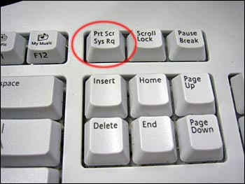
- Select a design you like by pressing Randomize at the bottom or using the toolbar to adjust color and design.
- When finished press PRINT SCREEN key on keyboard
- Open MS Word and press CTRL+V to Paste your Wordle in
- Double click on the picture (circles should appear around the edge)
- Click on Crop- Drag Black Corners to the area you want to crop- Click on the Crop button on your toolbar when you have your area you want to keep selected.

You will save this 2 times!
1. Click File- Save As- Computer (left side) Your Username (center under networks)
Save as: Wordle (your first and last name)
2. Click File- Save As- Computer (left side) Shared Drive- click on: Communications- Click on: your teachers folder with their name and Wordle (example Clarke Graffiti)- Save as: Wordle your first and last name.

